JANUARY–JULY 2019 REPORT
In 2016 Kibera Elite Soka Academy (KESA) was formed with the aim of establishing a soccer academy for the youth aged between 4 years and 8 years within an area known as Kianda in Kibra slum, who despite lack of appropriate gears, inadequate playing ground and raw talent has the desire to play soccer up to professional level.
The program has since grown with interest of those who wants to join from neighboring slums and estates rising. At KESA we have players from age 5-20 years. Our programs run from January to December
January, February, March, May, June, July, September, October program is always Academy and technification while April, August, November are soccer camps.
January-April program
Some of the activities we do with our players include the cleaning of our training field which is mostly used as the dumping site and besides all the odds we still manage to keep up with our soccer activities.
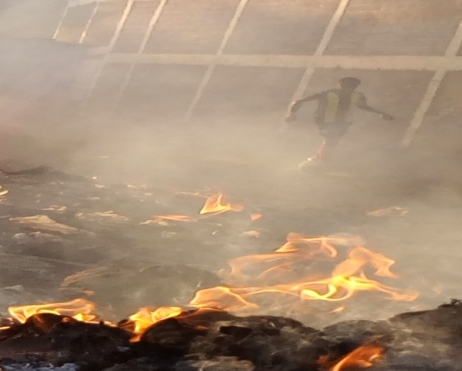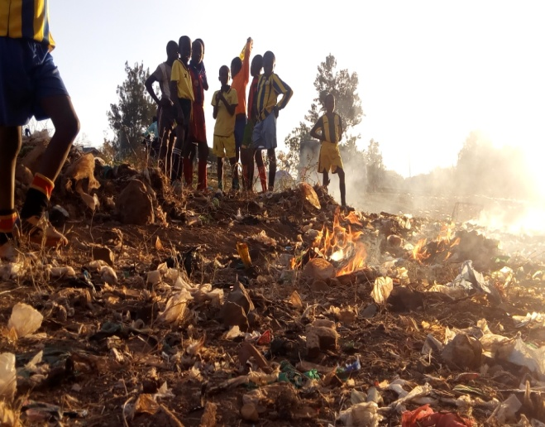

Soccer training and fun games
- Technification program. This is after school program that runs on weekdays. Objectives of this is to work on techniques and different skills.
- WEDNESDAYS-FRIDAY
- Time 5:00 – 6:45 pm

AGE 5-8 during the technification program
An after school program that runs from Wednesday-Friday from 5:00 pm-6:45 pm
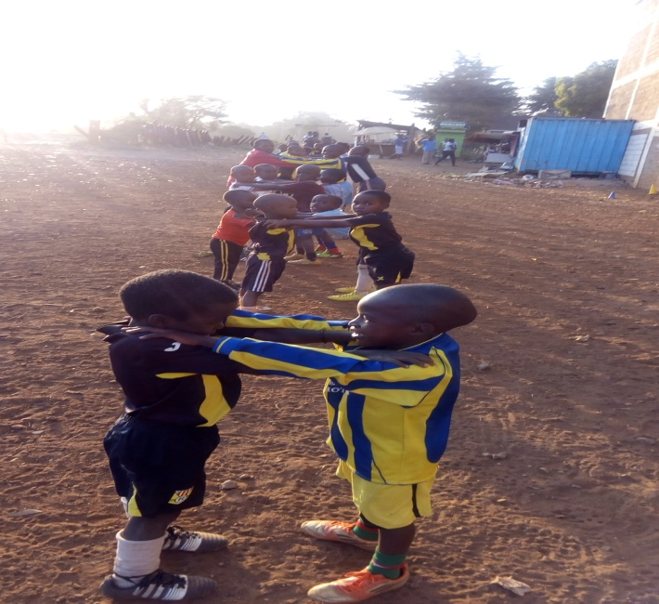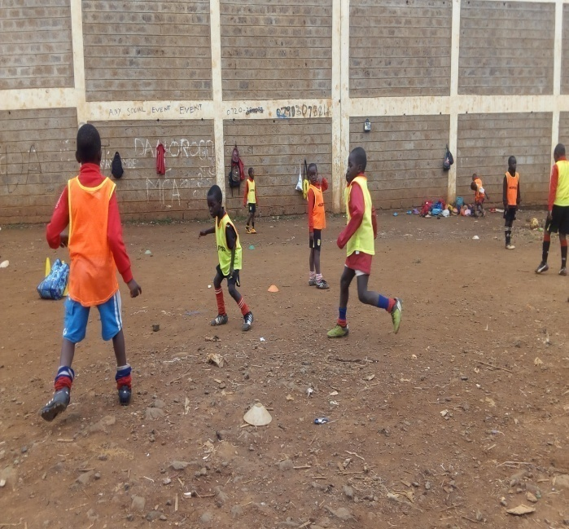
AGE 9-14 during technification program
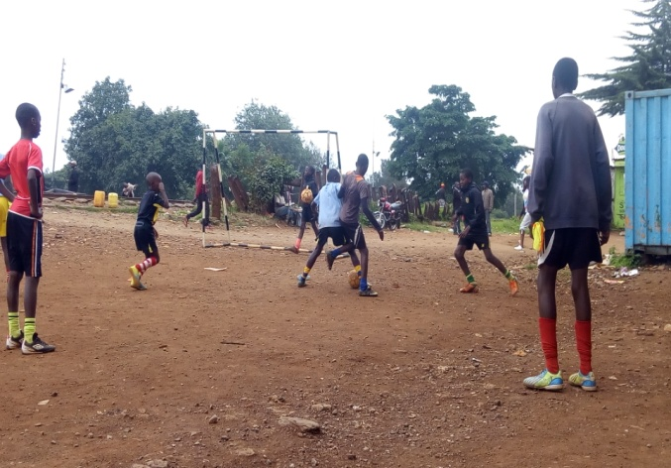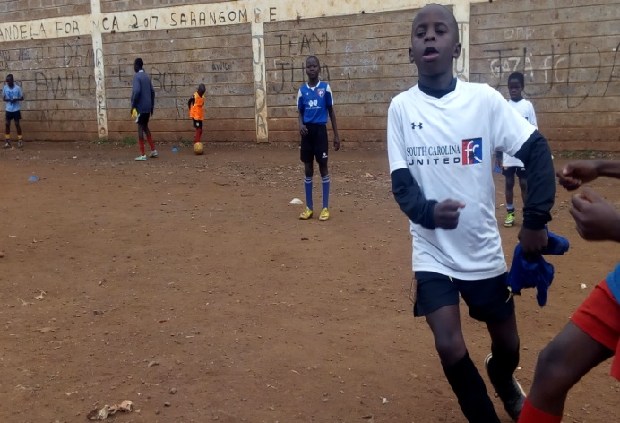
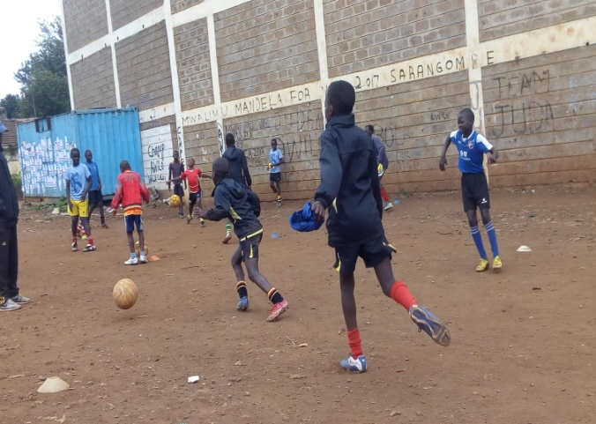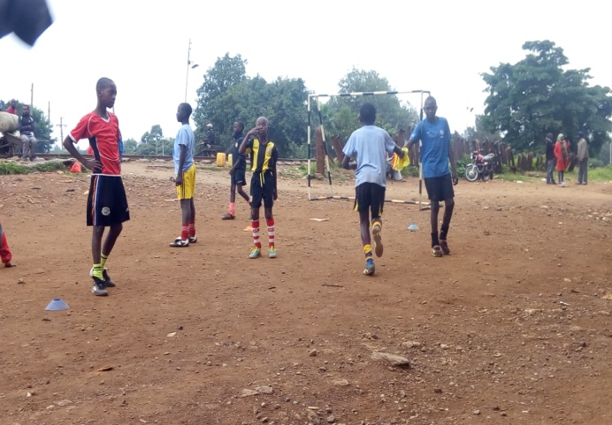

Saturday and Sunday Academy program
Achieving this dream has been one of the basic objectives of the project. An area with enough space where we get time and space to improve our skills.

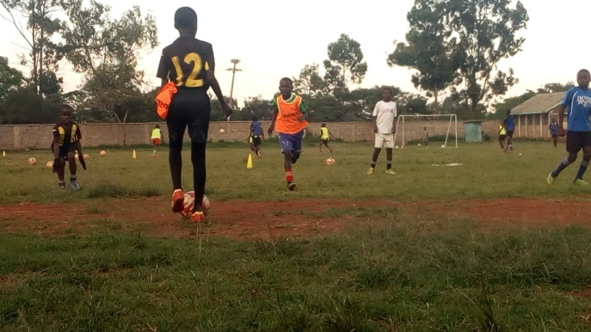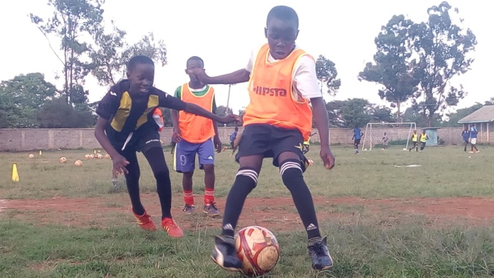

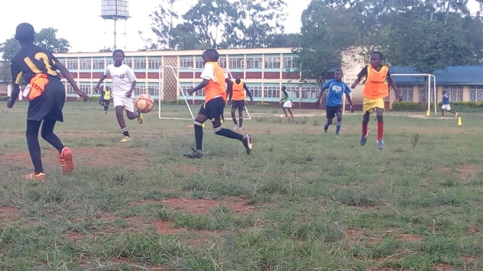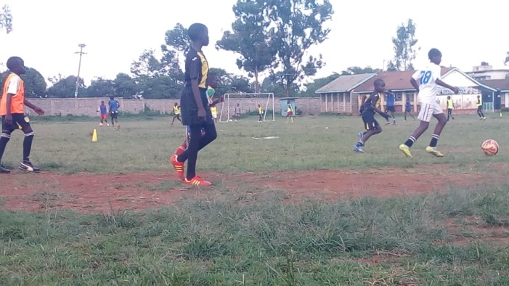

Games
Playing in different places in such facilities is always a great and a big exposure to our boys.

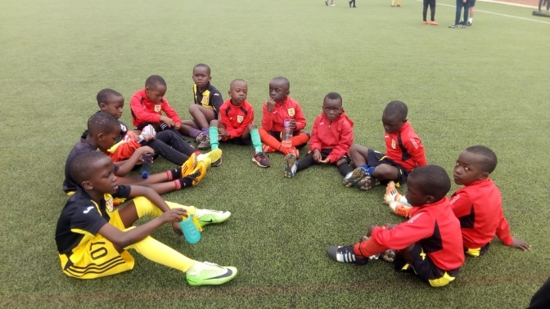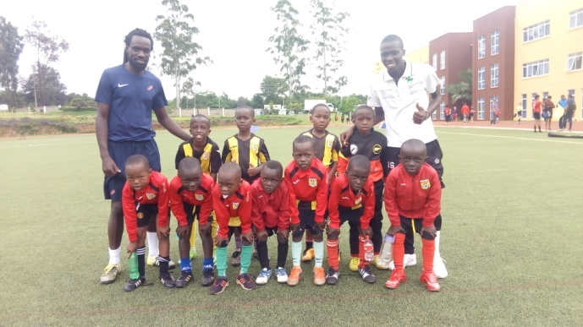

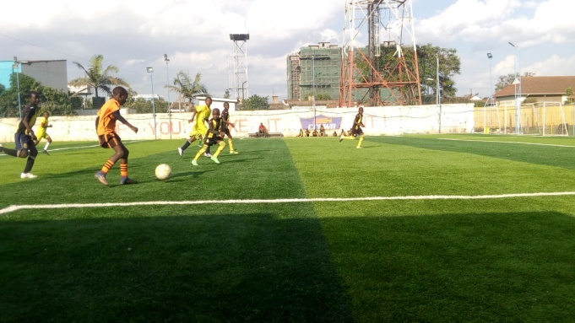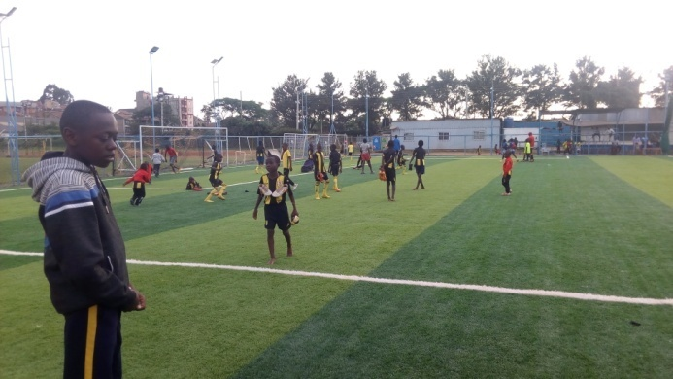

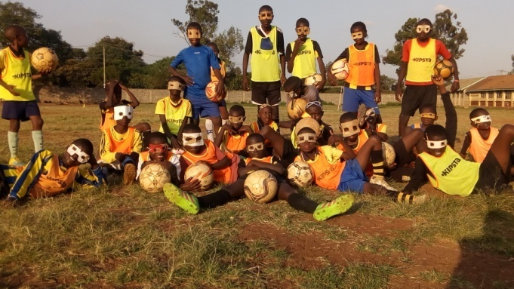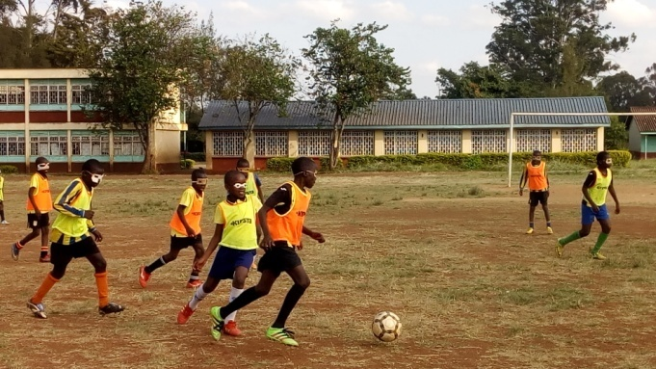

The KESA DAY.
This day is celebrated in every quarter of the year. One player is picked from the five categories of the academy which makes a team with 5 players and participates in the KESA DAY event. The three days tournament runs for three days.
April 2019
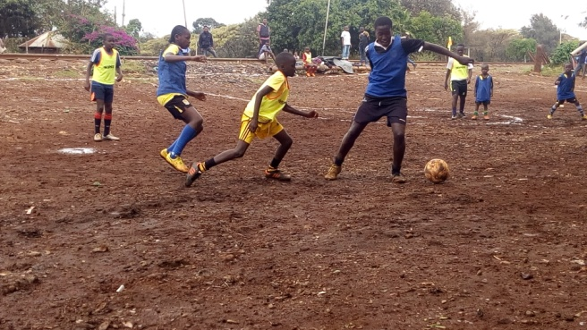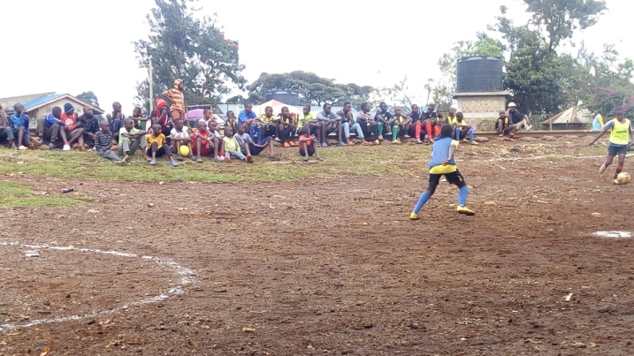

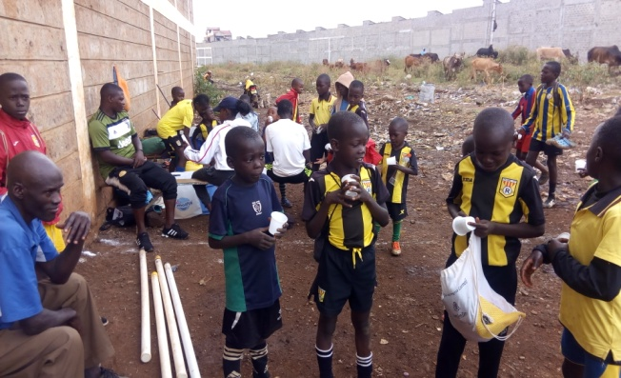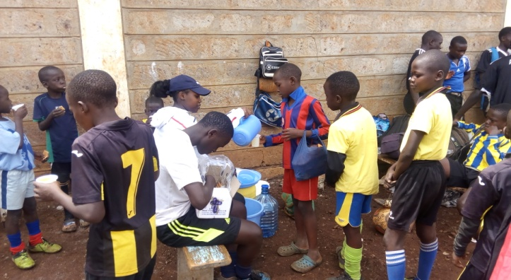

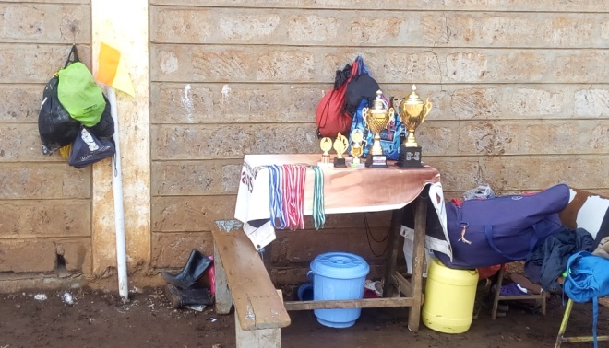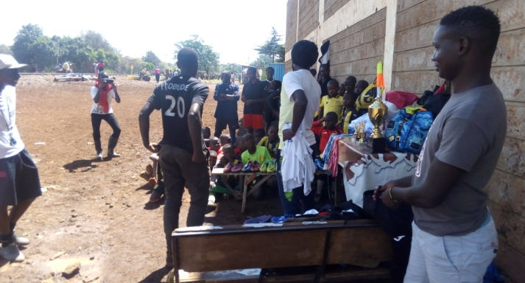

The winners in the first KESA DAY event that was held in April. The theme of this day is to have fun as a team.
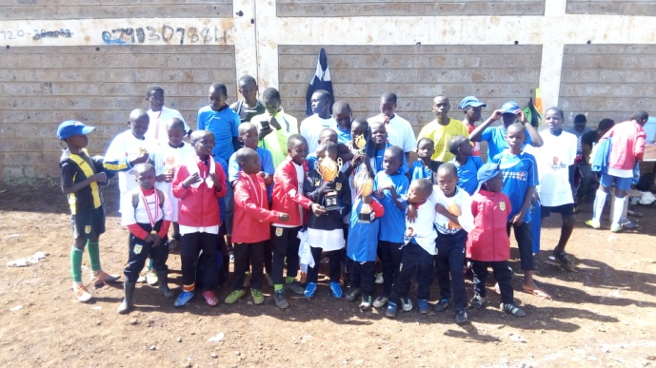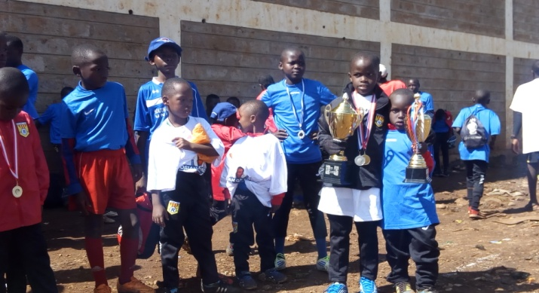

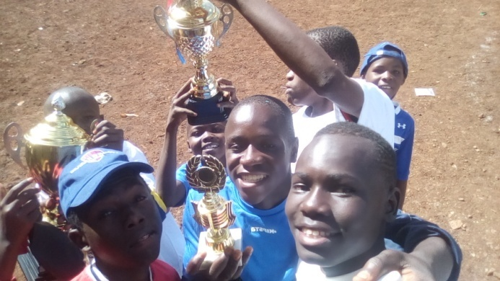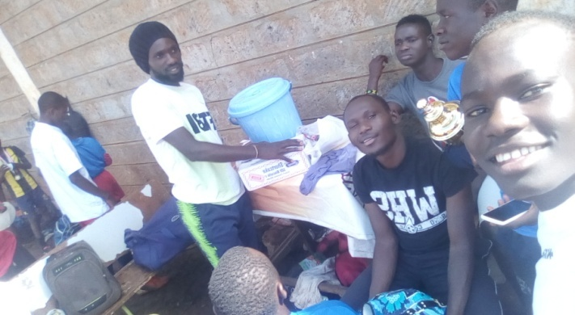

Soccer camps
This is held quarterly, bringing together both kids from boarding schools and day schools in a two/three weeks training. During this time of the year, we attend tournaments and community works like organizing clean ups.

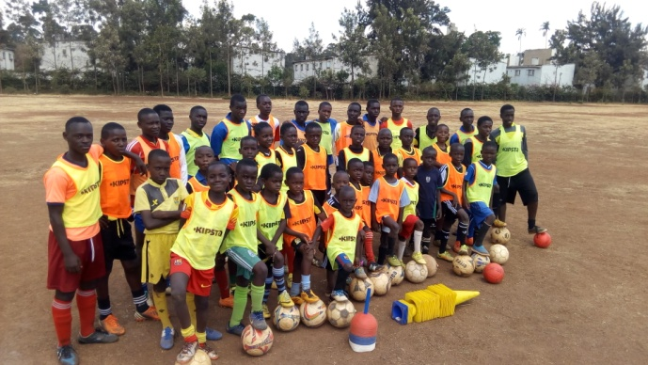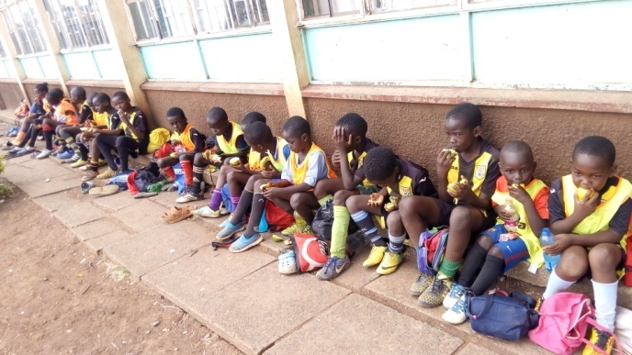
April soccer camp 2019
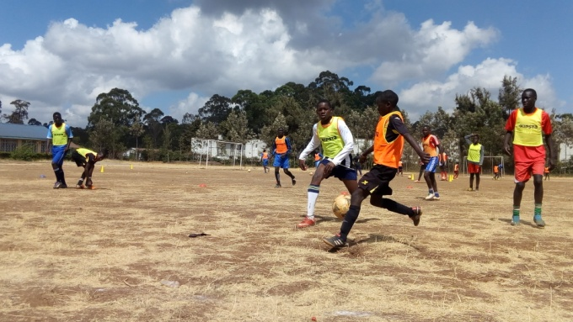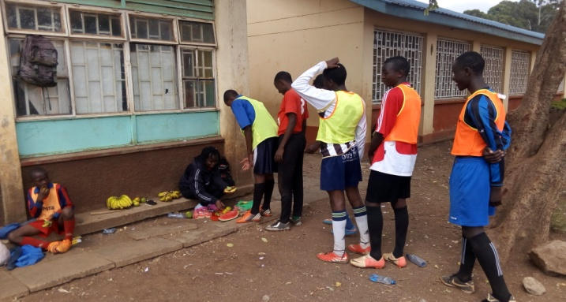
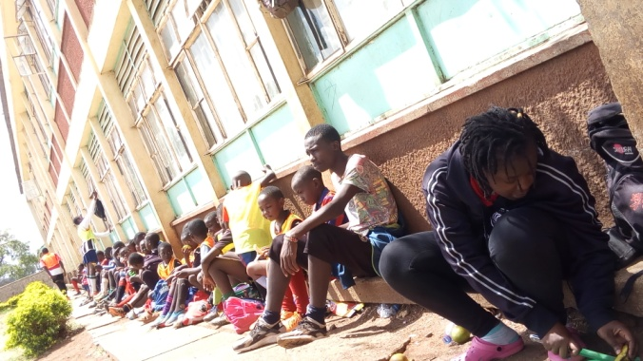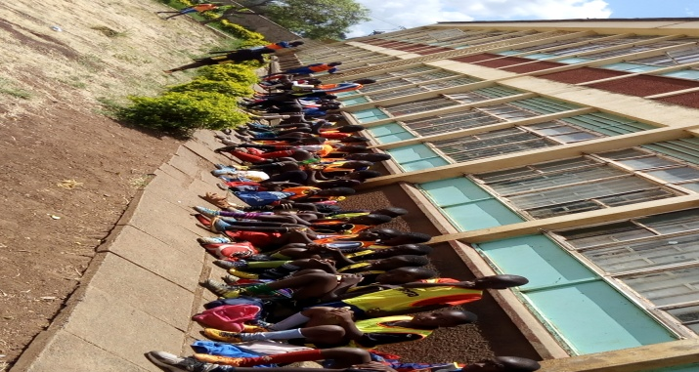

The Challenges faced during the time of activities
- We have 3 coaches who work as volunteers 5 days a week. There is need of hiring two more coaches to bring good quality of training
- Soccer field maintenance which costs Kshs.20,000 per month which includes security of some facilities like goal posts.
- Hiring a store/office for meetings and keeping our soccer equipments/facilities at kshs.2500.
- Soccer balls
DONATIONS 2019
MONTH/YEAR 2019 | NGO/GROUP/INDIVIDUAL | AMOUNT
Jan- Feb | - Fundacion cronos | Eur 200
Mar – April | - Fundacion cronos  - Youcanyole  - Marti Toress | Eur 200  Eur 200  15 pairs of soccer boots
May - June | - Fundacion cronos | Eur 200
July – August | - Youcanyole | - 2 soccer ballS  - 39 pairs of soccer boots  - Soccer kits
EXPENDITURE
MONTH/YEAR2019 | ITEM | AMOUNT( EUR )
Jan - Feb | - 2 months store rent  - Soccer field  - Ball repairs  - 3 Volunteer coaches | Eur 50  Eur 100  Eur 15  Eur 45
Jan/feb total expenditure |  | Eur 200
Mar - April | SOCCER CAMP ( 2 WEEKS )
 | - Soccer Field  - 2 months store rent  - Fruits  - Transport  KESA DAY ( 3 days fun games )  - 5 trophies  - 20 medals  - Snacks and drinks  - 3 volunteer coaches | Eur 150  Eur 50  Eur 40  Eur 5  Eur 130  Eur 40  Eur 38  Eur 60
Total expenditure |  | Eur 513
May – June | - 2 months store rent  Transport for Soccer games with age 7 and below  - 11 kids  - 2 coaches  - Water  2nd game transport for the age 13 and below  - Water  - 15 players/Kids  - 3 coaches/volunteers | Eur 50  Eur 39  Eur 5  Eur 45  Eur 5  Eur 60
Total expenditure |  | Eur 204

